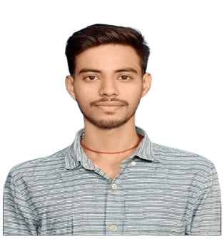

Registration Number: 23MCA10149

Email: mohit.srivastava.0002@gmail.com

Phone: +91 7277444964

www.linkedin.com/in/mohitsrivastava149

https://github.com/MohitSrivastava-149

**Mohit Srivastava**

**Technical Skills:** Java, React, Tailwind, Html, CSS, JavaScript

**Certification:** Java, SQL

|  |  |  |  |
| --- | --- | --- | --- |
| **EDUCATION** | | | |
| **Board** | **Tenure** | **Educational institution** | **CGPA/Percentage** |
| MCA | Aug 2023 - ongoing | Vellore Institute of Technology, Bhopal | 7.64 |
| BCA | July 2020 - Aug 2023 | L.N Mishra College of Business Management, Bihar | 70.78% |
| Class XII | April 2018 - Feb 2020 | M.B.B.L Inter College, Bihar | 66.6% |
| Class X | May 2018 | Paramount Academy, Bihar | 71.6% |

|  |  |
| --- | --- |
| **ACADEMIC PROJECTS** | |
| Web Development | * **Portfolio Website** * Description: Dynamic Portfolio showcasing my skill set, projects with my contact details. * Technology: React, Tailwind. * Individual Project. * Result and Link: https://github.com/MohitSrivastava-149/Portfolio |
| Web Development | * **Dictionary App** * Description: Basic layout of Dictionary application which shows meaning of searched word. * Technology: HTML, CSS and JavaScript * Individual Project. * Result and Link: https://github.com/MohitSrivastava-149/Dictionary-App |
| Web Development | * **To Do Lists** * Description: Developed a web-based To-Do-Lists application to enhance my skills in frontend development. * Technology: HTML, CSS and JavaScript * Individual Project. * Result and Link: https://github.com/MohitSrivastava-149/To-Do-Lists |

|  |  |
| --- | --- |
| CO-CURRICULARS | |
| Coding | Solved 100+ questions in GeeksforGeeks (30 medium). |

|  |  |
| --- | --- |
| EXTRA-CURRICULARS AND ACHIEVEMENTS | |
| Achievements | Participated in local Cricket Tournament |

|  |  |
| --- | --- |
| ADDITIONAL INFORMATION | |
| Hobbies | Playing Cricket  Playing Multiplayer Games |
| Languages | English, Hindi |